HealthPartners
Rating Service Design

Rating Service

Version Draft

1/19/2017

Contents

Contents
1. Project Executive Summary 4
1.1. System Overview 4
1.2. Design Constraints 4
1.3. Future Contingencies 4
1.4. Development guidelines. 5
1.4.1. Best Practices. 5
1.4.2. Standards. 5
2. System architecture 6
2.1. System Hardware Architecture 6
2.2. System Software Architecture 7
3. Database Error! Bookmark not defined.
3.1. Physical ERD Error! Bookmark not defined.
4. Infrastructure 10
4.1. General 10
4.2. Logging handling 10
4.3. Auditing 11
4.4. Exception handling 11
4.4.1. General 11
4.4.2. Custom Exceptions 11
4.5. Monitoring 11
5. Unit Testing 13
5.1.1. Method 13
5.1.2. Tested Components 13
6. Security 13
6.1. General 14
6.1.1. Web site security 14
6.1.2. Server security 14
6.2. Authentication 14
6.3. Authorization 14
6.4. Cross-site scripting (XSS) 14
6.5. SQL injection 14
6.6. Script injection 14
6.7. User input validation 14
6.8. Cryptography 14
7. Performance and Load Testing 14
7.1. General 14
7.2. Performance 14
7.3. Load Testing 14

Project Executive Summary

System Overview
The overall architecture will be a .Net 4.5.x web service supporting SOAP requests and responses. Officially, .Net CORE has been released and would be the preferred development architecture to give forward compatibility, application mobility, and general future-proofing, but .Net CORE does not support SOAP calls (in fact WCF has been eliminated entirely). In the HealthPartners environment, we still have difficulties with well-known SOAP implementation, and there has been little interest, discussion, or effort towards REST services. By continuing development with the older technology, we will:
- Reduce development timeline by not being first to implement
- Have options to implement a RESTful interface in the future
- Continue using existing practices for development and deployment.
The web service will track the data as XML. Each step of the process will be validating or adding data as necessary. The output will be rich data – we will provide a full data stream to show detail and allow the client to ignore data as they wish.
- The rate service will get a request with either a census list or a group/contract identifier. The service will validate that the existing data is correctly formatted.
- If the group/contract ID is used, we’ll pull the census from the MODS system.
- The service will validate the census to ensure any rules are applied.
- The service will identify the correct rate provider to use to pull the rates. This will probably be a fall-through method of attempting RateBrain, then Non ACA, then Dental unless an improved algorithm is described. Once the rate provider is identified, we’ll pull the age bands.
- The rate data will indicate the appropriate member rating algorithm, so we’ll rate the members based on the discovered rates and rate algorithm.
- Final validations will be run on the results, then the results will be returned.

Design Constraints
We will not implement any changes in the RateBrain database at this time. We expect state / federal legislation to continue to impact the business process, but we will rely on the existing RateBrain structures and the data provider interfaces described below to provide the necessary flexibility.

Future Contingencies

Development guidelines.

Best Practices.

Standards.

SOAP vs REST
The web service will be focused on a SOAP interface. SOAP interfaces use explicit XML and a data contract (specified in the WSDL). RESTful interfaces are stateless, use a more efficient JSON interface, but do not have an internal contract to determine data being passed. REST interfaces are built from the Javascript world for more efficient front-end web development.
In .Net, the most recent implementation of SOAP is to use WCF (Windows Communication Framework) which has been the standard since .Net 3.5. In .Net 4.6, Microsoft is abandoning WCF and implementing web services via RESTful interfaces. For other services, we provide both a RESTful and SOAP interface, but with the complexity of the structures we’re returning, this will not be part of the initial launch.
Again, as our organization does not use RESTful services as a standard yet, we’re going to implement with SOAP. In the future, we could create a wrapper service to implement a RESTful service by wrapping the SOAP service to reimplementing using the same libraries or attempt to use the REST over SOAP implementation we use in other apps.

Language
The project will be written in C#. While we’re starting development in version 5 (.Net 4.5 and Visual Studio 2012), our library code can be migrated to version 6 later – nothing we’re writing should break in the libraries. Version 6 is tied to.Net CORE, which drops support for the SOAP interfaces.

Database Queries
Database queries will be SQL in the code. Writing SQL statements in code allows detailed query logging and simplified migration. The RateBrain databases do not currently have production controls, so past experience has found database structures out of sync between environments. Performance during early development does not indicate that query speed will be an issue.

Database Connectivity
The web service will use SQL Server and Oracle connections. For SQL Server, .Net has the SQL server connectivity built-in. For Oracle connectivity, the current intention is to use the Oracle ODAC for .NET. This is an Oracle client installation, but we have been using a self-managed install for consistency that canbe deployed via xcopy. Ideally, we would move to the Oracle Managed Driver which is written in .Net and gives additional performance and features, but something is still not straightforward in how we need to configure it here in the HealthPartners environment to use the LDAP servers. Specifically, one server works with some names, but not all. The other LDAP servers fail to respond.

System architecture

System Hardware Architecture
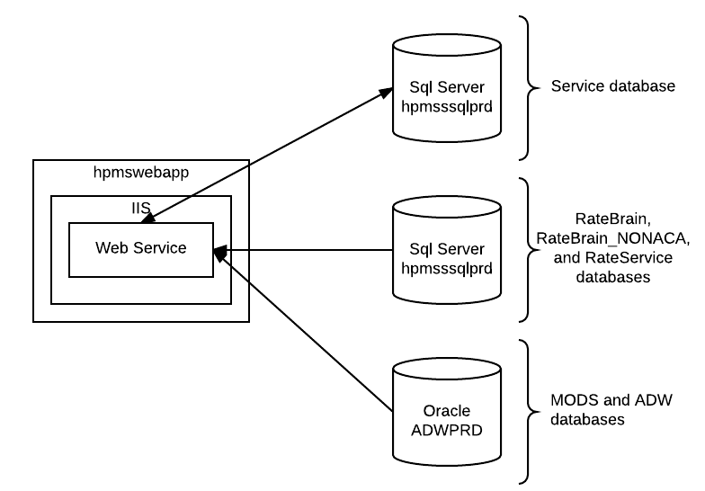
The web service will be hosted on hpmswebapp. Hpmswebapp is a virtual machine, so we will assume that it will provide enough availability to support the service.

Scale points:
- hpmswebapp can have resources extended for more power on a single point.
- The web service can be scaled across multiple servers. There are no user sessions, so simple round-robin load balancing can be used behind a load balancer.
- The SQL Server databases can have resources extended on the virtual machines or have databases separated across multiple servers if their utilization increases.
- The Oracle database is on RAC, so I doubt we’ll ever really impact their utilization.

System Software Architecture
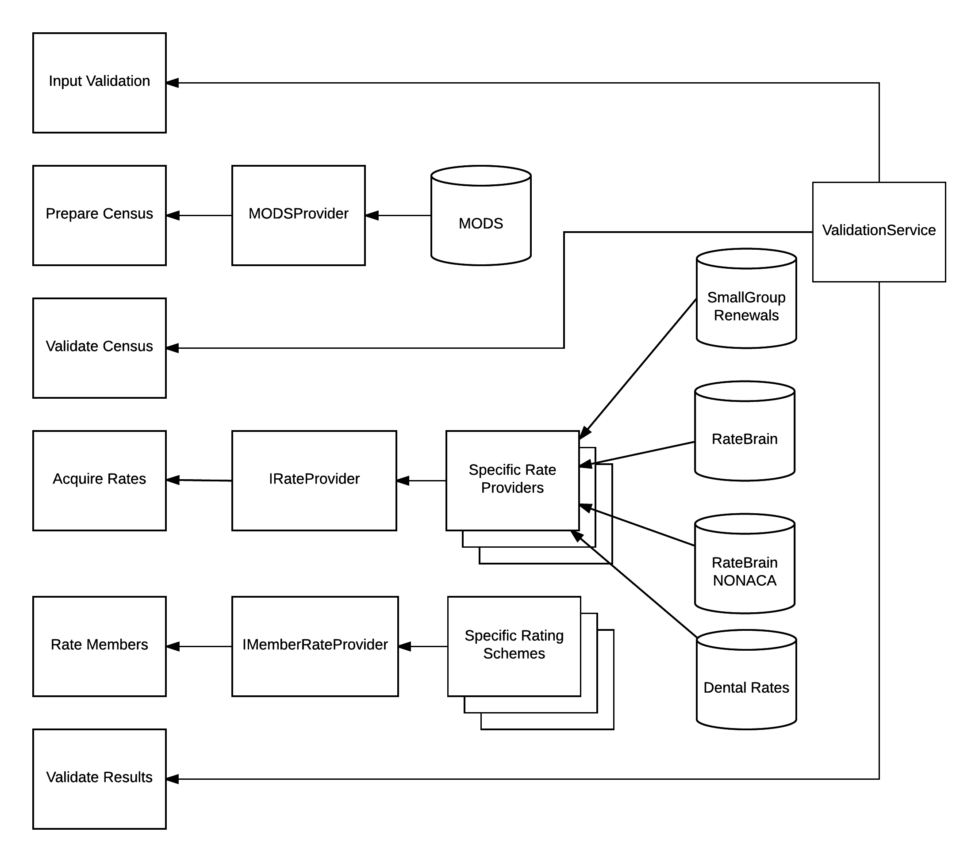

Interface Messages

Input Requests

By Contract – Individual Only
<GetRatesByContract>
<Plans>
<Plan>
<PackageCode />
<MACNetworkId> <!—- Either MACNetworkId or RateBrainNetworkId is required. -->
<RateBrainNetworkId> <!—- Either MACNetworkId or RateBrainNetworkId is required. -->
</Plan>
</Plans>
<ContractNum >
<EffectiveDate>
<County /> <!-- Required, only one allowed. -->
<State /> <!-- Required, only one allowed. -->
<ZIP /> <!-- Required, only one allowed. -->
</GetRatesByContract >

By GroupNumber – Small Group
<GetRatesByGroup>
<Plans>
<Plan>
<PackageCode />
<Network /> <!-- Required for Small group 2017, only one allowed. -->
</Plan>
</Plans>
<GroupNum>
<EffectiveDate>
</GetRatesByGroup>

By Census
<GetRatesByCensus>
<Plans>
<Plan>
<PackageCode />
<Network /> <!-- Required for Small group 2017, only one allowed. -->
</Plan>
</Plans>
<EffectiveDate /> <!-- Required, only one allowed. -->
<County /> <!-- Required, only one allowed. -->
<State /> <!-- Required, only one allowed. -->
<ZIP /> <!-- Required, only one allowed. -->
<Census> <!-- Required -->
<Family_Unit> <!--One for each contract -->
<Person> <!--Repeats for everyone in the family-->
<Birthdate /> <!--Not required, only one allowed. -->
<Gender /> <!--Not required, only one allowed. -->
<Tobacco /> <!--Not required, only one allowed. -->
<Relationship /> <!-- Required, only one allowed. -->
<Source_ID /> <!--Not required, only one allowed. -->
<FirstName /> <!--Not required, only one allowed. -->
<Middle /> <!--Not required, only one allowed. -->
<LastName /> <!--Not required, only one allowed. -->
<Age /> <!-- Required, only one allowed. -->
<IsMedicalSub /> <!—Optional. If is true, will count as medical member.
<IsDentalSub /> <!—Optional. If is true, will count as dental member. Somewhere in the future.
</Person>
</Family_Unit>
</Census>

</GetRatesByCensus>

Success Response

Response (responds with original data as well as response data, response is in bold)
<RateResponse>
<Plans>
<Plan>
<PackageCode />
<Network /> <!-- Required for Small group 2017, only one allowed. -->
… Rate factors …
<Rate Area></Rate Area>
<Effective_Date /> <!-- Required, only one allowed. -->
<Census Rate MedicalSubscriberRate> <!-- Required -->
<Family_Unit Rate MedicalSubscriberRate > <!--One for each contract -->
<Person > <!--Repeats for everyone in the family-->
<Age /> <!-- Required, only one allowed. -->
<Sex /> <!--Not required, only one allowed. -->
<Tobacco /> <!--Not required, only one allowed. -->
<Relationship /> <!-- Required, only one allowed. -->
<Source_ID /> <!--Not required, only one allowed. -->
<Name /> <!--Not required, only one allowed. -->
<Birthdate /> <!--Not required, only one allowed. -->
<Rate />
<MemberID /> <!—If pulled from MODS -->
<IsBillableFlag /> <!—Boolean -->
<IsMedicalSub /> <!—Optional. If is true, will count as medical member.
<IsDentalSub /> <!—Optional. If is true, will count as dental member. Somewhere in the future.
</Person>
</Family_Unit>
</Census>
<AgeBands>
<AgeBand>
<Description />
<Min_Age />
<Max_Age />
<Gender />
<NonTobaccoRate />
<TobaccoRate />
<RateBandType />
<Gender />

</AgeBand>
</AgeBands>
<ValidationMessages>
<Validation >
<Status />
<Message />
</Validation>
</ValidationMessage>
</Plan>
</Plans>
</ RateResponse >

Database

Logical ERD
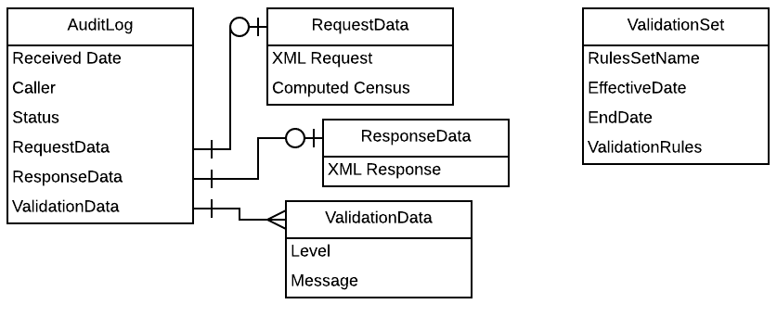

Physical ERD
Physical ERD represents the actual design blueprint of a relational database. It represents how data should be structured and related in a specific DBMS. It will include Link Tables, Primary keys, foreign keys and any constraints needed. Should include server names or IP addresses.

Infrastructure

General

Logging handling
Logging for the application will use log4net. This allows multiple benefits:
- Disk is cheap
- The disk must be available for the system to operate, and will be available if the database fails.
- The system can scale on the disk more quickly.
- Disk has less performance impact than database storage
- The data does not need a consistent format.
- We can shift structure of the log with the application online.

Auditing
Auditing will rely on database tables. See the Logical ERD for details.

Exception handling
Exceptions will include data validations.

General

Custom Exceptions

Monitoring

Libraries

Services

Validation Service
Each validation point will have a named XSLT transformation. The XSLT will contain the validation rules. When it’s run, the output will be the validation messages.
The validation provider will support multiple levels – only error and warning will be put in the output. Other types should be logged.
Error messages will prevent further processing.

Validation Implementations:

Input:
Package Code | The Package Code must exist  The package code cannot be blank  The Package Code cannot have multiples
Effective Date | The Package Code must exist  The package code cannot be blank  The Package Code cannot have multiples

Data Providers

MODS Provider
We will base member data on the Oracle MODS database ADWPRD. The query is similar to the query from small group, but adds the MODS.prod_ds table to get the CorpID and LicenseState.

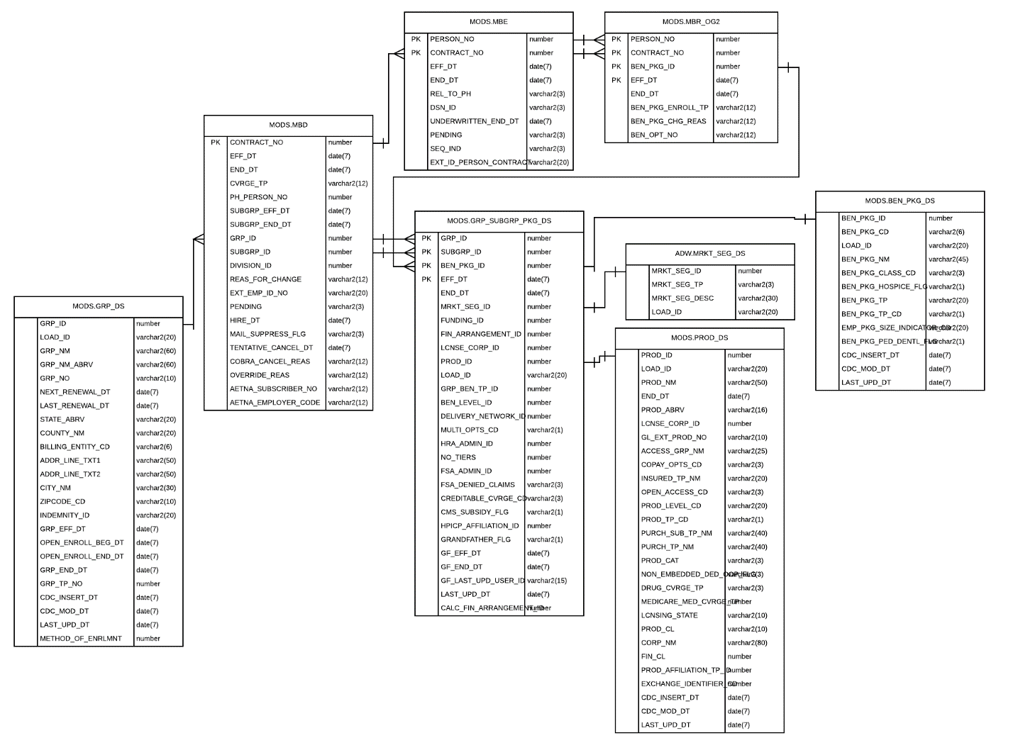

Two separate queries will be run: One to return the group/subgroup/package info, then another to determine the members and relationships.

The group / subgroup / package data will return first to include the current corp.

The members and relationships will be in the second call.

IRateProvider Interface
The IRateProvider interface will specify these methods:
- GetPackageDetails(PackageCode, Network, EffectiveDate) - Returns null if the provider has no information on the passed plan. These are the plan-level details, with elements in a 1:1 ratio to the package code.
- GetPlanAgeBands(PackageCode, Network, EffectiveDate) – Returns an XElement with the plan information. Note that GetPlanAgeBands should determine if the maxRateArea logic should be triggered.

RateProviders
A Rate Provider will be created for each type of rate. These will be specific implementations of IRateProvider for:
- RateBrain (Small Group ACA and Individual) (See RateBrain ERD)
ERD in use is only shared as PDF. See RateBrain ERD.pdf

** Because the RateBrain ERD schema is a looping disaster, the query has to have all joins built together. If it returns more than 1 row, throw the exception and pass it on.

- NonACARateBrain
- Dental

MemberRateProvider Interface
The MemberRateProvider interface will support:
- RateMembers(XElement Census, XElement PlanInfo): For each family, identify the members that are billable, compute the amount for the member, then create the sums.
The initial Implementations of MemberRateProvider will be:
- Max3And21Plus – DepCountMethod = 1 in the plan
- Max3 – DepCountMethod = 2 in the plan
- AllMembers – DepCountMethod = 3 in the plan

Unit Testing

Method
Visual Studio Unit Tests in a dedicated Unit Test project.

Tested Components
New systems will have dedicated tests for each component and attempt to hit 100% coverage. Existing methods will be trusted.

Security

General

Web site security

Server security

Authentication

Authorization
For PCI applications we may want to include the following 6.4 – 6.8.

Cross-site scripting (XSS)

SQL injection

Script injection

User input validation

Cryptography

Performance and Load Testing

General

Performance

Load Testing

